**Results of Prototype Test Assignment**

**What did you hear and observe from users or experts?**

During user testing we showcased 3 solutions, website platform, chabot AI platform, and an application based on android.

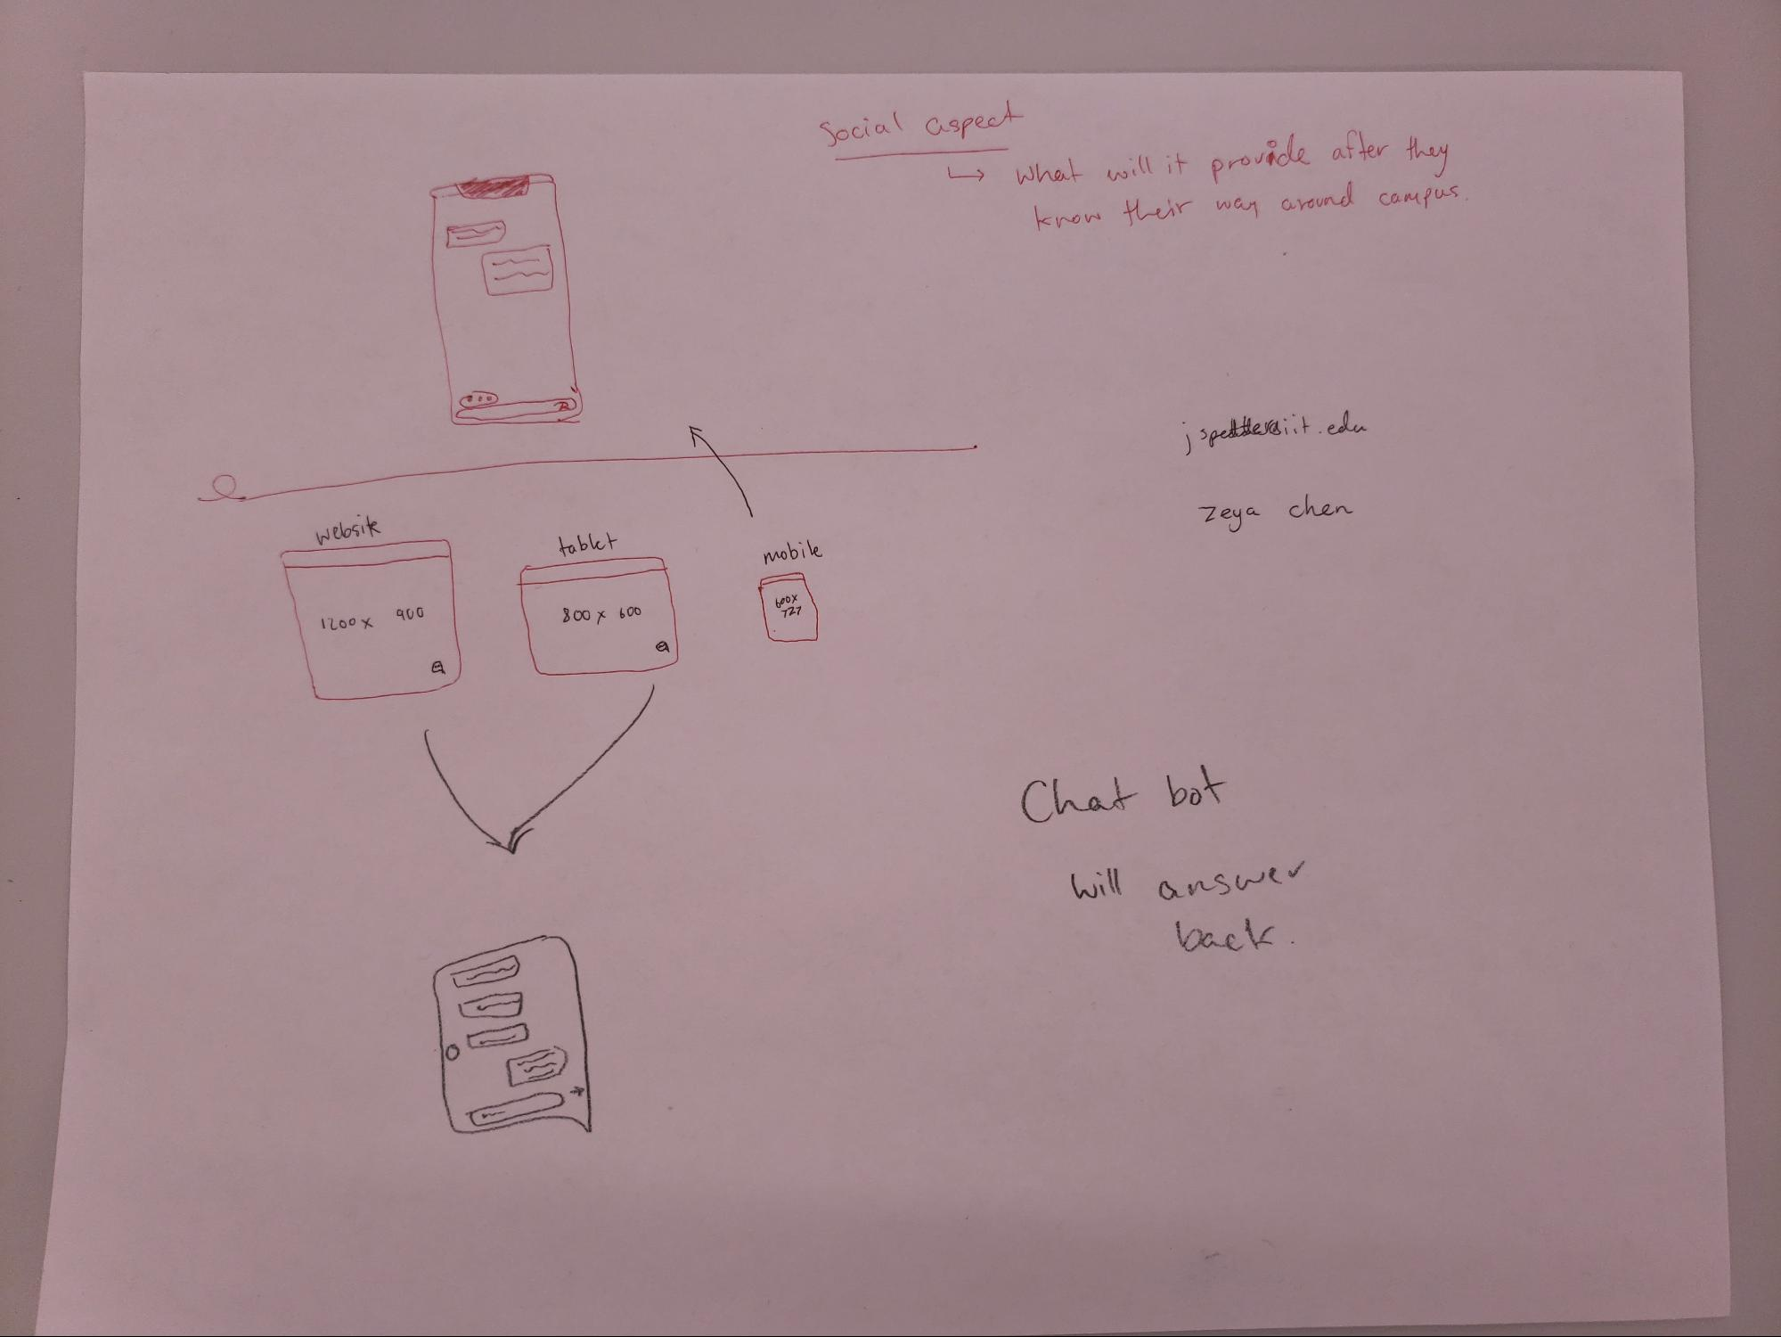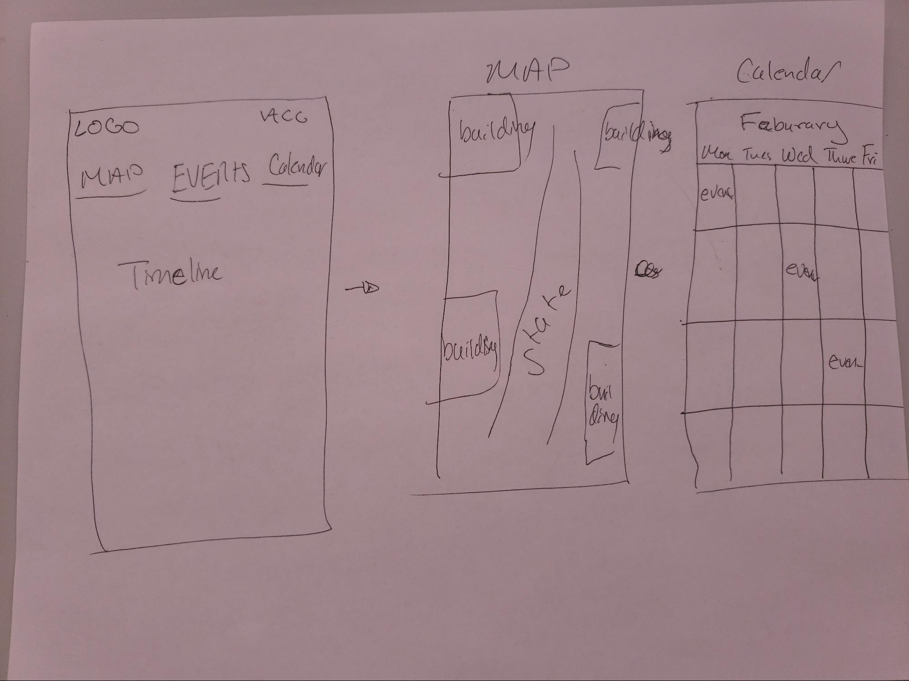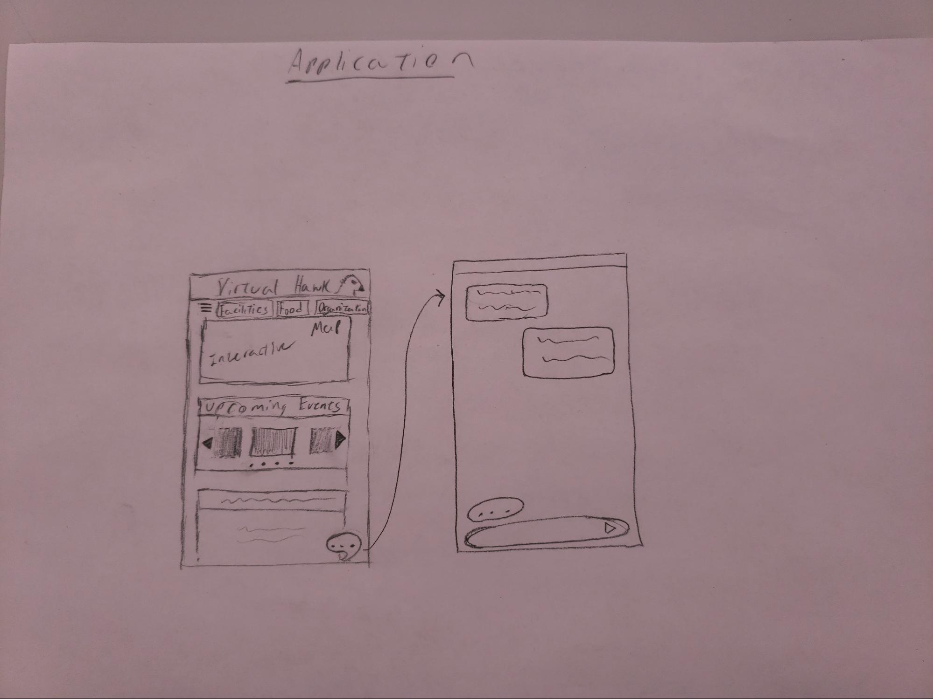

**What did they say worked? What did not? What questions did they have? Did they have any ideas for making the concept better?**

The mobile application was received with mixed reviews. They recommended implementing the following features:

* Photos will help, having acronyms will help find things faster.
* A search feature will have things in order to find things faster. "I want to click on events and a feature where it will tell you this is where this event is today.
* Classes in the building rooms when you click on it. <- Possible implementations
* Emphasize -> IIT specific events and bringing where it is on campus.
* Find where stuff is in the buildings.

The major downside to the mobile application is that it is not a cross platform. The application will be android only, so only students with android devices will be able to access our platform. This will limit market size and user testing.

Feedback on the website was mostly positive. There were no critical issues found, but recommendations for improving the platform were provided. One of the possible improvements includes the ability to look through all the events, click on it, and it will give me information and a search bar to increase data finding capabilities.

Chatbot feedback was received with more harsh criticism. The lack of a gui posed a problem for the ease of access. Searches for example, “Where is my club meeting at?”, would return the location in a text based format with no map to guide the user. Other issues included finding a specific IIT event that the user is unaware about/do not know the name. One of the positive sides of this technology is that it would provide quick responses to what and where information and simple directions.

**Did the tests reveal any ethical issues? For example, would the idea cause any population undue harm, put them at risk, or make them feel uncomfortable?**

Ethical issues for all our platforms include knowing user information including their schedules, location, and access to general IIT data. All three platforms would require access to all three things. Users would not be comfortable sharing their schedules/IIT data, since a data leak/hack could put all the users at risk. Location is another sensitive information users would feel unsafe to use since their location would be monitored at all times while our platforms are running.

**What feedback and/or data suggests that this is the strongest idea to move to the next release?**

Out of our three solutions that we presented, the website contracted the most reactions from our user test group. The gravitated towards the website due to it’s easy accessibility, cross platform compatibility, and ease of use. The application came in a close second, but due to its restriction of OS, the website was found to be the easiest to develop and have a larger market across the different OS ecosystems. Due to the nature of website development, implementing features would be easy. All content and updates would be server side, so the users will not have to download any data on to their devices. The website is the most versatile and fluid choice when it comes to design and features. We will be implementing user suggested features such as a search feature, building layouts, and emphasising IIT events on our menu.